GENIE Version 4 User Notes

The Genie Homepage

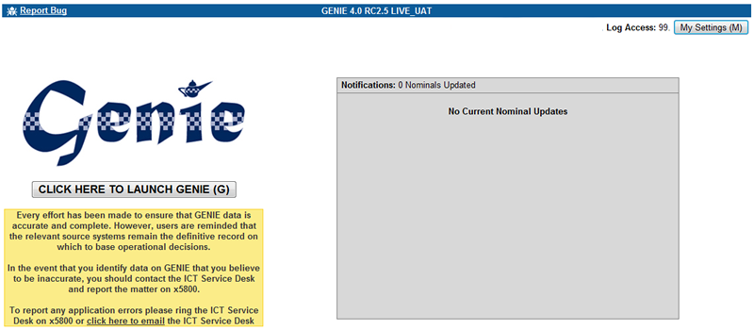

Changing Your Settings.

You can change your settings on any screen within GENIE by pressing the `My Settings (M)` button in the top right of the window or by pressing ALT + M.

The My Settings screen will then open.

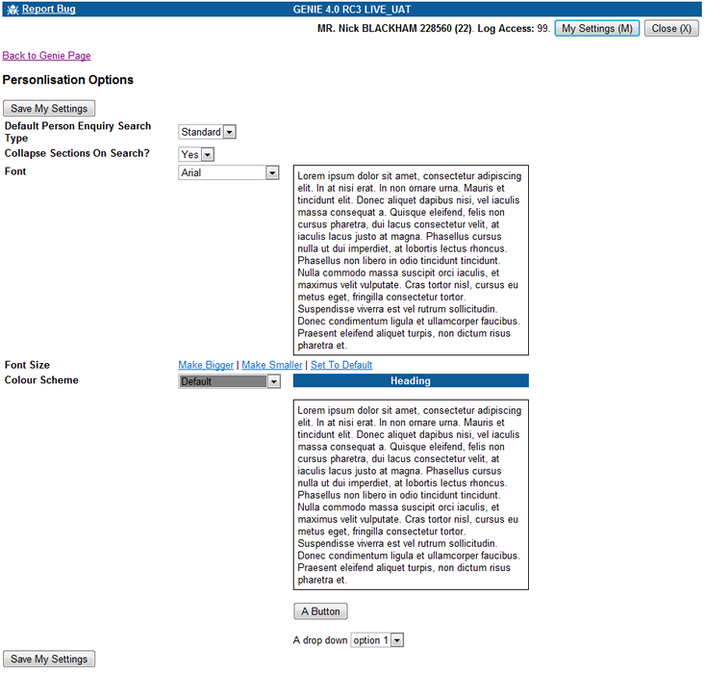
The following settings can be changed on the My Settings screen.

- Default Person Search Enquiry Type. Options are Standard and Wildcard. The default is Standard. Changing this option has the effect of selecting the Person Search Enquiry type to your setting by default.

- Collapse Sections on Search. Options are Yes and No. The default is Yes. Selecting no will stop the sections on each search screen minimising when you click search.

- Font. Options are Arial, Verdana, Trebuchet, Times New Roman. The default is Arial. This changes the screen font throughout the GENIE application. It DOES NOT change the fonts used in any printing or pdf document creation, these cannot be changed.

- Font Size. You can make your font bigger or smaller by clicking the `Make Bigger` and `Make Smaller` links. The default font size is 10pt. Clicking `Set to Default` will return the font size to 10pt.

- Colour Scheme. 10 Colour Schemes are available. If you select a scheme different to your current scheme the screen will change to reflect that colour scheme.

When you have finished changing your settings click the `Save My Settings` button to commit the changes. Then click the `Back To Genie Page` link at the top of the screen to return the page you were on when you clicked `My Settings`.

Note : Any other existing GENIE windows will not automatically change to the settings you have selected. These must be closed and reopened to reflect the changes you have made.

The Main Menu

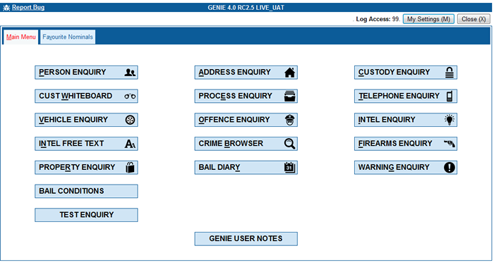

GENIE defaults to the Main Menu tab where the enquiry options are located

Favourite Nominals tab click this tab to find your saved favourites
This tab will be display your list of ‘Favourite Nominals’. You can then link to these nominals directly without having to do a separate search.

All Enquiry Screens now open in a New window.

DPA Reason

When opening an enquiry screen you will be asked for your Data Protection Act Reason. You cannot continue to the Enquiry Screen without completing this box. If you open an enquiry screen in error then click the Red Cross in the top right corner to close the enquiry screen. There is no need to complete the DPA information if you have opened the screen in error.

The DPA Reason box requires you to enter 3 pieces of data.

- Requestor. If you are doing this on behalf of another person (eg. Comms Op doing a check for an officer over the radio) you must complete the details of the person you are completing the enquiry for. Enter their details (eg collar no or surname) and tab out of the box to complete the details. If the enquiry is for you personally then pressing CTRL+M will default your details into the field, or you can search on your surname or collar no.
- Reason. Enter the Reason code or select the Reason from the drop down list. Completing either Reason code or selecting from the list will automatically populate the adjacent field.
- Details. Free text field for information on why you are conducting the enquiry
- *** OCC Users Only. PNC Paste.

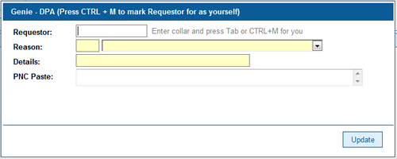

DPA Reason Timeout

On every enquiry screen once a search has been conducted a countdown begins until the DPA Reason you have entered times out. The default period for this is 5 minutes as requested by the Professional Standards Department. Certain roles in the organisation have a longer timeout period.

Once the timeout period has expired the START SEARCH button on each enquiry screen is removed. When this happens the user must click the NEW ENQUIRY button and enter their DPA Reason again before conducting the next search. Whilst the START SEARCH button is still available users can continue to conduct as many searches as they like. However, should their DPA reason need to change they must click NEW ENQUIRY to enter new DPA details.

Options on All Enquiry Screens

Every enquiry screen has a set of links above the search form

Clear Form | Expand All | Expand With Data | Collapse All

Clear Form – This resets the Enquiry Screen to the state it was in when you first opened it. Quick Key = ALT + C

Expand All – Opens all sections on the Enquiry Screen

Expand With Data – Opens all sections on the Enquiry Screen where data has been entered by the user

Collapse All – Closes all sections on the Enquiry Screen

When a search is performed all sections are collapse by default.

Special Fields

Date Fields

Date fields are now masked so that you can only enter date format data. An example of a date field is on the Custody Enquiry, Date of Arrest. When you enter the field the text dd/mm/yyyy will be displayed. You can type a valid date into the field just by typing the numeric characters eg for 01/01/2015 just type 01012015.

Time Fields

Time fields are now masked so that you can only enter time format data into them. An example if a time field is on the Custody Enquiry, Date of Arrest. You can just type the numeric characters of a time in, eg. 07:30 type 0730. You can also use the up and down arrows to change the hour / minute values and the left and right arrows to move between the hour / minute values.

Lookup Fields (Previously known as List of Values [LOV])

Lookup fields allow you to type some text into them and will then search for what you have entered. The search will commence 1 second after you have stopped typing. An example of a lookup field is on the Property Enquiry, Category field.

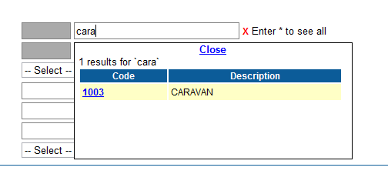

Once the options have appeared click a link within the results to select the option. This will then be selected in the search field.

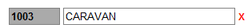

To clear a lookup field click the Red X next to the field.

Person Enquiry

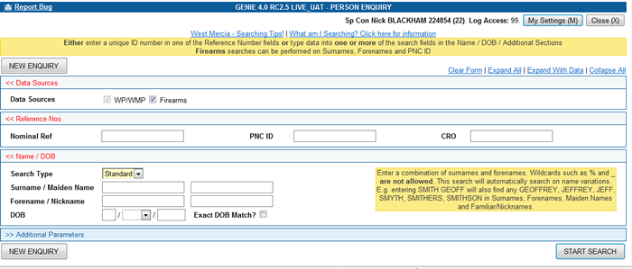

Important information about CRIMES and NSPIS Custody/Case Preparation nominals
In the event that a nominal is not tied between NSPIS Custody/NSPIS Case Preparation and CRIMES a temporary nominal reference is generated to identify the record.
If you select one of these temporary nominal records all that you will be able to view for the nominal is the selected custody or case preparation data. Even if the nominal is known to CRIMES, unless the user has tied the record through the NSPIS applications the detail will not be visible.
Systems available for search:
CRIMES
NSPIS Case and Custody
West Mercia Firearms Certificate Holders
West Midlands Regional Data Warehouse (Authorised users only)
Links available from result sets
Data held on CRIMES for selected nominal (see above regarding temporary nominals)
Data held on NSPIS Custody for selected nominal
Summary of OIS incidents for CRIMES Crime records where nominal had a role
Data held on NSPIS Case Preparation for selected nominal
Offender Management System (OMS). Prisoner marker will be present for ALL current prisoners not just those being released shortly. The marker will remain on the screen for up to 14 days after the nominal’s release date.
IOM and PPO Markers – Should a nominal have a warning marker on CRIMES of Integrated Offender Management or Priority and Prolific Offender this will now trigger an information box (originally triggered from JTRACK).
Most recent photograph taken of nominal in a West Mercia Custody unit
Summary data held on COMPACT for selected nominal
Summary data held on CRS (Road Traffic Collisions) for selected nominal
Authorised users can view forensic images on DAMS (Digital Asset Management System) related to crime records.
Summary data held on West Mercia Firearms System for selected person
STEP package data (Including Quick Step Task Allocation Packages - a red box will appear on a nominals record with a link to the Quick Step Package details.)
RMP Risk Management plan data
ASBO/CRASBO information from the Anti Social Behaviour Collector System is included. When a nominal has been flagged with a record on Collector a marker will be displayed on the nominal record.
Stop Searches – a tab has been added to the nominal details screen that shows stop searches that the nominal has been subject to. (will only show Stop Searches recorded via the new paperless process)
Section 27 When Section 27 details are available for a nominal these will be displayed via the Sec 27 tab on the nominal information screen.
Links to West Midlands nominals, addresses, telephones and vehicles (Authorised users only)
NB. You will need to view the original database if more detailed information is required

Authorised users can now search the West Midlands Regional data warehouse during a search by ticking the West Mids tick box.

A Firearms search for summary data held on West Mercia Firearms System, for the selected person, is included by default (See below for more information on searching)

Search Hit Count

When data is retrieved during a search, the tabs will display the number of hits retrieved for each of the searches. (West Mids Authorised Users - NOTE: care should be taken when interrogating West Midlands regional responses as these can be easily misunderstood)

Once a search is carried out the Actions drop down list becomes available.

Actions drop down list:
Submit NIR (National Intelligence Report)
Opens the NIR submission screens.

Submit PNC Wanted
Clicking this allows the user to open a streamlined STEP package for completion. This is a more structured method of creating, managing and reviewing risk of PNC wanted individuals. This IS NOT a direct link to PNC.

Submit Stop Search
FCR (force control room only) Staff are able to submit Stop Search, via this actions drop down list. A pop up box requires the details of the officer conducting the action and their location. Clicking the submit button then opens the relevant form.

There are 4 separate sections within the Genie Person Enquiry screen (Data Sources, Reference Numbers, Name / Dob, Additional Parameters)

- The Reference Numbers section:

- Cannot be used in conjunction with any of the other 3 sections.

- Enter a unique ID number in one of the fields (Nominal Reference, PNC ID or CRO Number) then click the ‘Start Search’ button.

- A unique ID number is the most effective way of finding a nominal.

- A Firearms search can be carried out with a PNC ID number but bear in mind a PNC ID number may not have been entered on a feeder database (i.e. CRIMES) so you need to consider also carrying out a name search as per the criteria below:-

- A Firearms search can not be carried out using the nominal reference number or a CRO number..

- In previous functionality, if only one nominal is found from a search performed GENIE would open the Person Detail screen immediately. Now this will only happen when the user has searched on NOMINAL-REF and a match has been found.

- Name / DOB Search section:

- Search Type Field – Options Standard or Wildcard. (you can set your default option in the My Settings section of GENIE).

STANDARD SEARCH

- Caution – ensure the data you enter is in the appropriate field (i.e. surname in the surname field, forename in the forename field) The Standard Name Search does not do an ‘either way around’ search.

- Enter a combination of surname(s) and/or forename(s).

- Wildcards such as % and _ are not allowed.

- The Standard Name Search will automatically return name variations:
For example, entering the surname SMITH and the forename GEOFF will also find SMYTH, SMITHERS, SMITHSON, and GEOFFREY, JEFFREY and JEFF

NB: If a maiden name is recorded on the system, entering the maiden name details in the surname field will also return name variations.

- Can be used in conjunction with the Additional Parameters section:
For example, to narrow down the above search (GEOFF SMITH) you could also add a date of birth or age range, specify someone’s sex, place of birth, postal town, maiden name and/or nickname. However the fields: age range, sex, place of birth, postal town, maiden name and/or nickname are not searchable fields in Firearms.

- The Standard Name Search section cannot be used in conjunction with the Reference Numbers section.

- Results under the Firearms tab will include some name variations e.g. searching on DAVIES Bert will return DAVIES and DAVIS also Albert, Robert and Hubert

WILDCARD SEARCH

- The Wildcard Name Search section does carry out an ‘either way around’ search (i.e. if you type a surname in the forename field and vice versa, it will search all name combinations)

- Results under the Firearms tab will include an “either way around” search

- Results will not include name variations e.g. Rich, Richard, Dick

- Enter a combination of surname(s) and/or forename(s)

- Wildcards such as % and _ are allowed.

- Use Wildcards to fill in any unknown characters:
For example, entering the surname SM%TH% and the forename GE% will find SMITH, SMYTH, SMITHERS, SMITHSON and GEOFF, GEOFFREY, GERRY and GERALD But not JEFF and JEFFREY.

NB: If the maiden name is recorded on the system using the wildcard search fields also carries out an either way round search.

- Can be used in conjunction with the Additional Parameters section:
For example, to narrow down the above search (GE% SM%TH%) you could also add a date of birth or age range, specify someone’s sex, place of birth, postal town, maiden name and/or nickname. However the fields: age range, sex, place of birth, postal town, maiden name and/or nickname are not searchable fields in Firearms.

- The Wildcard Name Search cannot be used in conjunction with the Reference Numbers.

NB: Double barrelled names e.g. PERRY-SMITH enter PERRY% in the first wildcard surname field and %SMITH in the second wildcard surname field.

NB Triple barrelled names e.g. VAN DER SAAR enter VAN% in the first wildcard surname field and %SAAR in the second wildcard surname field.

Please refer to section (5) for more on multiple forenames, double barrelled names and triple barrelled names

- The Additional Parameters section:

- Must be used in conjunction with the Standard Name Search section or the Wildcard Name Search section.

- Cannot be used in conjunction with the Reference Numbers section.

- It is not possible to carry out a search with just a Maiden Name or Nickname in this section.

- It is not possible to carry out a search with just a Date of Birth, Age Range, Sex, Place of Birth or Postal Town.

i.e. you must also include a surname and/or forename in the Standard Name Search or Wildcard Name Search sections.

NB: When you enter the full Date of Birth details in the appropriate fields GENIE will automatically perform a 5 years either side search. If you are very confident on the date of birth details you can reduce the number of returns by making use of the exact date of birth tick box.

NB: When you enter just the year of birth GENIE will automatically perform a 5 years either side search.

- Results under the Firearms tab work in the same way.

- Alias name searches have been improved. Previously, items such as ‘Post town’ would only work properly when searching on a primary nominal. Now the same search will work if the name being searched on is an alias for the primary nominal.

- Multiple forenames, double barrelled names and triple barrelled names

Records with more than two forenames i.e. Richard David Smith will be created as follows. i.e. one name per box.

Surname
Smith

Forename
Richard
David

Consider searching names either way round and leaving out middle names as they may or may not be included in the existing records. Also consider carrying out a further search using only the middle name, using standard or wildcard searches as appropriate.

Even if you get a result consider refining your search yet again to see if there are any duplicate records. Have you definitely found the definitive record?

One word surnames i.e. “Jackson” will be created in the first surname field.

Double Barrelled Names

Rules and conventions stipulate that double barrelled names should be created as per the following examples. There is no need to add a hyphen as it is automatically added by the system.

Andrew Stephen MORGAN-JONES

Surname
Morgan
Jones

Forename
Andrew
Stephen

Triple Barrelled Names

Triple barrelled surnames should be created as follows. There is no need to add a hyphen as it is automatically added by the system.
Susan Lillian VAN-DER PLANK

Surname
Van
Der Plank

Forename
Susan
Lillian

Lauren MONIZ-DE JESUS

Surname
Moniz
De Jesus

Forename
Lauren

William Phillip ST JOHN-COOPER

Surname
St John
Cooper

Forename
William
Phillip

Double and triple barrelled surnames should be searched as follows:-

NB - To allow for inconsistencies in data quality the recommended search criteria for double and triple barrelled names is to make use of the wildcard search facility as per the examples below.

MORGAN-JONES

Surname
Morgan%
%Jones

Also consider other options e.g.
%Morgan%

VAN-DER PLANK

Surname
Van%
%Plank

Also consider other options e.g.
%Plank%

- Favourite Nominals Search:

Rather than having to do a nominal search every time for a ‘regular’ nominal, you can now create a ‘favourite’ for the person in question.

To do this search for the nominal in one of the ways indicated above, select the nominal, then:-

1) Click the ‘add as favourite’ button at the top of the screen.
2) A confirmation message will be displayed.
3) Click on ‘Nominal Details’ to take you back to the nominal detail screen.

To initiate the ‘Favourite Nominals’ Search

1) From the Main Menu – click on the ‘Favourite Nominals’ tab
2) Select your chosen nominal from the list.
3) Enter your audit code and update the reason if necessary.
4) The person detail screen will open

When accessing this tab, the VISOR nominals for your division (as defined on your ORIGIN Self-Service page) will be displayed below your list of ‘Favourite Nominals’. You can then link to these nominals directly without having to do a separate search.

As part of IOM (Integrated Offender Management) users can select whether they wish to be notified of updates to their favourite nominals when they log into GENIE. The following updates are available:-
New role in a crime
New address
New custody
New Intelligence
New vehicles
New telephone numbers
New warrants
New associates

Users will be notified of any changes to a nominal when they open up the GENIE home screen. Notifications will only appear for a nominal when they have an update since the last time a user logged on. The information is updated once a day at 06:45.

(You cannot add a nominal to your favourites from the Firearms results)

- Functionality:

On the nominal detail screen, telephone numbers and vehicles tabs have hyperlinks that automatically launch the respective Telephone Number and Vehicle Enquiry screens. The search will automatically run on clicking the link.

Data from the CRS (RTC) System is now included. If a known nominal is identified as being involved in an RTC then a cross-reference will be made on the CRS system and consequently on to GENIE. (see Screen Improvements for more information)

Once a nominal search has been carried out Command and Control users will see a Submit Stop Search button at the top of the screen allowing them to generate a stop search form.

- Screen Improvements

If a person is currently ‘Missing’ then this will be flagged up in the same way as the warning signals markers.

If the Date of Birth or Date of Death are estimated, this will be indicated.

Roles tab – Will show if a suspect eliminated flag has been set and the date filed for the crime is also shown. The Crime document will also contain the date filed, eliminated flag and the date eliminated.

Vehicles tab - If a known nominal has been linked to a vehicle involved in an RTC, you will be able to see this through the ‘Vehicles’ tab from the Person Detail screen. From here you can click on the link to see more details about the RTC. The RTC document also contains links similar to that for the crime document. From within the document, you can also link to other nominals and vehicles that were involved.

Nominal features – nominal features on GENIE are only updated after changes on CRIMES. Changes made to nominal descriptions in other systems like NSPIS Custody or COMPACT are not reflected on GENIE and this can cause some confusion. Current policy states that PNC should be used as the definitive record for nominal description data and a message has been added to the top of the “Features” tab that reminds users of that fact.

FP(U) tab – All nominals flagged as subject of a Child Protection Plan on CRIMES FPU screens are given a marker on the nominal details screen.

You can sort by date as well as log reference number on the IRAQs tab.

(M)ISP tab - has been modified to remove the OIC field. Address and Date Found are displayed instead.

Pac(k) tab - Step Packages - A red marker will only be shown for current packages. Clicking on the package reference number will hyperlink you directly to the STEP package itself. Historic packages can be viewed under the Pac(k) tab

Occs(J) tab – Multiple occupations are now recordable on CRIMES and can be viewed under this tab.

(W)arn tab – Warning markers can be given an expiry date on CRIMES. Only markers that have not expired will be displayed in the red boxes on a nominal details screen. This new tab will display the complete list, both current and expired.

Src(H) Tab – This tab shows Stop Searches that a nominal has been subject to. This will only show stop searches that have been recorded via the new paperless process.

Sec 2(7) tab - When Section 27 details are available for a nominal these are displayed via the new Sec 27 Tab on the nominal information screen. If the Section 27 is current then a red warning box is also displayed.

RM(P) tab - Risk Management Plans are differentiated and are coloured according to their type.

If a nominal is not linked to a nominal reference it means that the person is not known to the Force for any other reason.

Address Enquiry

Once a search is carried out the Actions drop down list becomes available, with the option to submit intelligence via submit NIR.
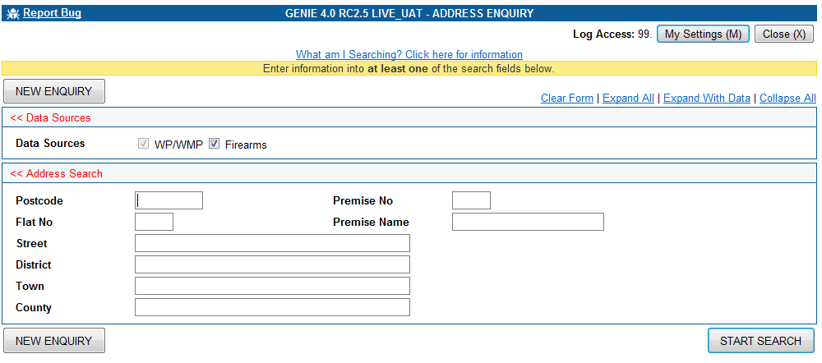

Systems available for search:
Address Details from CRIMES
Address Details from NSPIS Case Preparation
Address Details from NSPIS Custody
Address Details from West Midlands Regional Database (Authorised users only)
Address Details from West Mercia NFLMS records.
Links available from result sets
Link to CRIMES nominal information for selected address (See Person Enquiry)
Link to CRIMES offence information for selected address
Link to OIS Incident record for selected address where a crime was recorded
Link to Local NFLMS record for selected address where a firearm is recorded
Links not available
Any data held on NFLMS (National Firearms System) (Outside West Mercia Area)
Links to any system not specified above

Important information about Address Enquiry hits
GENIE will only return hits where information has been linked to that address. If no results are returned the address may be valid but no information has been linked to it.
West Midlands Regional Addresses
Authorised users only

- All fields are free text and there are no lists available for postcodes, street, district, town and county

- You need to remember that CRIMES address records contain abbreviations such as Rd (road), St (street), Av (avenue), Cl (close) etc. However, Custody records will have a variety so the search protocols here will change. To achieve the best results you should apply the following rule:

Example: Greenbank R% - will return Rd and Road
Greenbank St% - will return St and Street

- Postcodes in both CRIMES and Custody are entered with a space.

Example: WR8 1AA, SH14 2AB

The results list includes a button linking to the Safer Neighbourhood Team (SNT), if the address is a Warwickshire or West Mercia Policing Area Address. A tally of Nominals, Offences, Organisations and Intelligence Logs at the address (click the address hyperlink for full information or the number itself to see the last 10 offences, nominals, intel logs ), and a link to a MAP (this is a google map of the address and relies on the Internet connection being available).

A firearms search is carried out as default but remember the current firearms address rules must still be applied. Ensure you use R% for road so that CRIMES, NSPIS and Firearms are all searched.

Firearms address search fields include:
House no and street in the same field i.e. street field
Town
Postcode

Offence Enquiry

Systems available for search:
CRIMES crime records
Links available from result sets
Summary of OIS incidents for CRIMES Crime records where nominal had a role
Links not available
Complete CRIMES Crime record information
Data held on any other system not specifically mentioned

Greyed out fields on the Offence Enquiry screen have a text box next to them to type in. Eg WMC Recorded As. See Special Fields – Lookup Fields section for use of these boxes

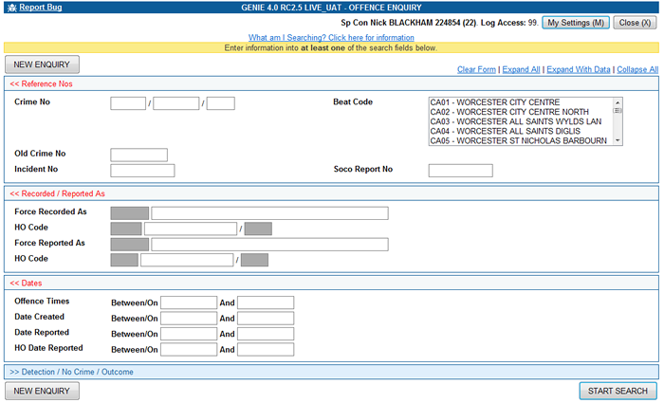

Functionality:

A Full Document and a Summary Document are available. The Summary document should be practical for release to partner agencies and solicitors.

Authorised Users can view information held on DAMS (Digital Asset Management System) to view forensic images related to crime records. The link will open up the DAMs application in a new window. The user then has to select which exhibit they wish to view before photographs are displayed.

All Genie Users will have access to non restricted images. If images are restricted and the user does not have access to the images then a message is displayed in the right hand portion of the screen below informing the user that they do not have access.

VRM’s listed in the property section of a Crime Report and details section of an NIR will be a hyperlink which, when clicked, will automatically open and run a vehicle enquiry.
Custody Enquiry

All the fields on the custody enquiry screen allow you to search

LOV
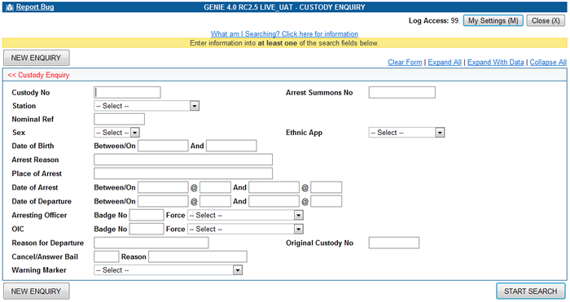

Systems available for search:
CRIMES Custodies
NSPIS Custody Custodies
Links available from result sets
Full custody record information from NSPIS Custody (not CRIMES Custody)
Link to CRIMES nominal information for selected custody (See Person Enquiry)
Links not available
Any data held on OIS for selected custody
Data held on any other system not specifically mentioned

Custody Whiteboard Enquiry

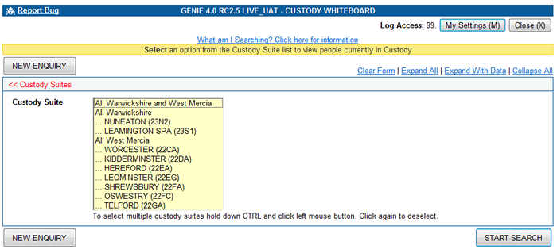

One search field available.

Selecting `All Warwickshire and West Mercia` brings back every person in Custody Across the Alliance.

Selecting `All Warwickshire` brings back every person in Custody in Warwickshire Police custody suites.

Selecting `All West Mercia` brings back every person in Custody in West Mercia Police custody suites.

All other options are individual custody suites. You can select multiple custody suites by holding down the CTRL Key and clicking the relevant option. Clicking the same option again will deselect it.

You can mix individual custody suites with All Force options. Eg. All Warkwickshire and KIDDERMINSTER (22DA) selected will give you all Warks Custody suites and Kidderminster. However it should be noted that selecting All Warwickshire and West Mercia will override all other options.

Systems available for searching:

- Current CRIMES Custody where a nominal is being detained
- NSPIS where a nominal is being detained

Links available from the Results screen

- Link to CRIMES nominal information for selected nominal reference (See Person Enquiry)

Links NOT available

- Data held on any other system

Process Decision Enquiry
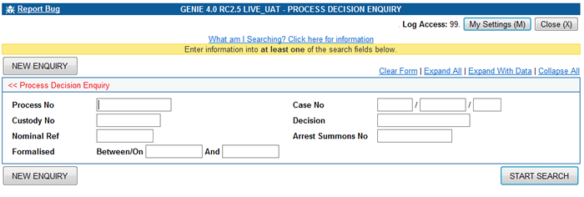

All fields are available for searching.

Systems available for search:
Process / Case Details from CRIMES
Process / Case Details from NSPIS Case
Links available from result sets
Link to CRIMES nominal information for selected process/case (See Person Enquiry)
Link to NSPIS Case Documents
Link to any NSPIS Custody Documents involved in the case
Links not available
Link to CRIMES Case Documents

Vehicle Enquiry

Once a search is carried out the Actions drop down list becomes available, with the option to submit intelligence via submit NIR.
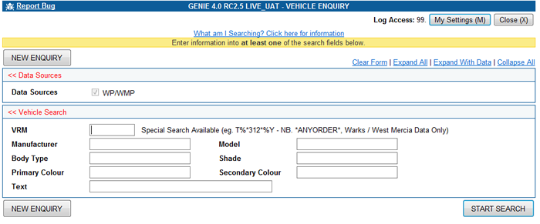

The Vehicle Enquiry screen has been designed in a similar way to Property Enquiry with one major difference – the search fields for Manufacturer, Model, Body Type, Shade, Primary Colour and Secondary Colour DO NOT contain Lists.

All fields are available for searching.

Systems available for search:
Vehicle Details recorded in CRIMES Intelligence log
Vehicle Details recorded as CRIMES Property
Vehicle Details associated with a defendant on NSPIS Case Prep
Vehicle Details associated with a known nominal on CRIMES from the CRS (RTC) system
Vehicle Details recorded on West Midlands Regional Database (authorised users only)
Links available from result sets
Link to CRIMES nominal information for selected vehicle reference (See Person Enquiry)
Link to CRIMES offence information for selected vehicle property reference
Link to CRS (RTC) information
Links not available
Details of RTC’s where Vehicles are not tied to CRIMES nominal
Data held on any other system not specifically mentioned

West Midlands Regional Vehicles
Authorised users only

Vehicles linked to RTCs will be displayed. The RTC document also contains links similar to that for the crime document. From within the document, you can also link to other nominals and vehicles that were involved.

If a nominal is not linked to a nominal reference number it means that the person is not known to the Force for any other reason.
Telephone Enquiry

Once a search is carried out the Actions drop down list becomes available, with the option to submit intelligence via submit NIR.

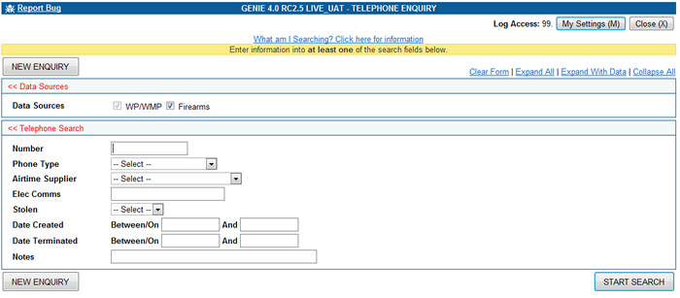

Systems available for search:
Telephone Number / electronic communications related to a CRIMES address
Telephone Number recorded in CRIMES Intelligence log
Telephone Number recorded in NSPIS Custody record
Telephone Number recorded in NSPIS Case Preparation record
Telephone number recorded on OIS where number is the telephone number called from
Telephone number recorded on West Mercia NFLMS Licence Holders
Telephone Number recorded in West Midlands Regional Database (authorised users only)
Links available from result sets
Link to CRIMES nominal information for selected telephone number / id (See Person Enquiry)
Link to NFLMS details
Link to Incident Log from OIS
Links not available
Data held on any other system not specifically mentioned

West Midlands Regional Telephone Numbers
Authorised users only

A firearms telephone number search is carried out by default. The other fields are not searchable options on firearms.
Property Enquiry
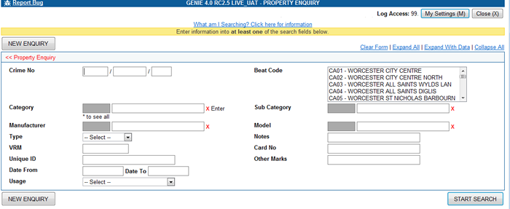

Systems available for search:
All property recorded on CRIMES that has been recorded in relation to a crime.
Links available from result sets
Links to crime records for selected property
Links not available
Links to Property recorded through intelligence
Links to vehicles for specific property reference
Data held on any other system not specifically mentioned
Note: Only VRMs recorded as property through a crime will be displayed. To look for generic vehicle usages, use the Vehicle Enquiry Screen.

The Genie Property Enquiry facility is searching CRIMES Property pages.

There are no mandatory fields on Genie Property Enquiry. Any combination of search fields can be used.

Crime Number:

Enter a full or partial Crime Number (the wildcard % symbol is allowed)

Beat:

Enter a full or partial Beat Code (the wildcard % symbol is allowed)

Category and Sub-Category:

There are over 100 categories of property on CRIMES, and each one is then further divided into sub-categories.

See Special Fields – Lookup Fields for more information on how to use this.

Once a Category is selected, only the appropriate Sub-Categories will be available.

Manufacturer and Model:

Either type your search data into the relevant field(s)

See Special Fields – Lookup Fields for more information on how to use this.

Once a Manufacturer is selected, only the appropriate Model(s) will be available.

Type:

There are 5 types of property on CRIMES:
- Document
- General
- Vehicle
- Pedal Cycle
- Weapon

Treat this search with caution, as it can be difficult to choose the correct type. For example, a Vehicle Excise License is recorded on CRIMES under the Vehicle type (not Document as may be expected)

Try not to use Category and Sub-Category together with Manufacturer and Model. A more effective search would be: Category and Sub-Category or Manufacturer and Model

Notes: (NOT previously searchable on Crimes Property)

When a property record is added to CRIMES, the operator can add additional information to a freetext field (a description of jewellery, for example). This is where Genie is searching when you type data into the Notes field.
(Wildcards % are allowed)

VRM:

Genie is searching CRIMES Property records.
Enter a full or partial Vehicle Registration Mark
(Wildcards % are allowed)

VRM’s listed in the property section of a Crime Report will be a hyperlink which, when clicked, will automatically open and run a vehicle enquiry.

Card Number:

Enter a full or partial card number (e.g. bank card, credit card)
(Wildcards % are allowed)

Unique ID Number:

Enter a full or partial unique identification number (e.g. chassis number, engine number, cheque number, serial number)
(Wildcards % are allowed)

Other Marks:

When a property record is added to CRIMES, the operator, following set Rules & Conventions will add additional information to the ‘ freetext ‘other marks’ field.
The operator will always start this field with the Beat Code for the location of the offence (e.g. DB)

The operator will then add:
- The colour if the property is a vehicle or a pedal cycle.
- The word ‘inscript’ if the property had an inscription.
- The postcode if the property was postcoded.
- A mobile telephone number if a mobile phone was stolen.
- The word ‘clone’ if the property has been cloned (e.g. credit card)
- A partial Vehicle Registration Mark if the full VRM is unknown.

Date From and Date To:

Genie is looking at the date(s) Property is recorded on CRIMES.
Enter date(s) in full (DD MMM YYYY format)

Usage:

When searching for property you can now also search on USAGE to narrow down your search (e.g. USED, ATTACKED, STOLEN, etc)

Intelligence Enquiry
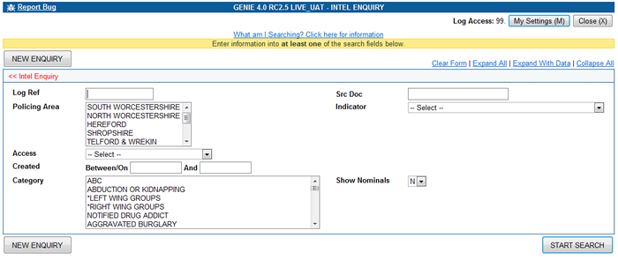

Systems available for search:
CRIMES Intelligence Logs (all headers are available). However, you will only be able to view those records up to and including your log access level . (Warwickshire Intelligence being submitted via GENIE from Oct 2013.)
Links available from result sets
Link to Intelligence Log for selected search parameters
Links not available
Data held on any other system not specifically mentioned

The Genie Intelligence Enquiry facility is searching CRIMES Intelligence pages.
There are no mandatory fields on Genie Intelligence Enquiry. Various combinations of search fields can be used.

Log Ref:

Enter a full or partial Intelligence log reference number (wildcard(s) % are allowed)

Src Doc:

Use the drop down menu from the LOV (list of values) to select the appropriate Source Document. User can then add /insert the document number to search for an appropriate document. Also consider selecting the appropriate Source Document from the list of values, then adding a % (wildcard) before carrying out the search. E.g. BAIL%

Policing Area:

Use the drop down menu to select the appropriate policing area (from Oct 2013 inc Warwickshire).
Indicator:

Use the drop down menu from the LOV (list of values) to select the appropriate Indicator. User can then add /free text using a wildcard (%) if necessary, to refine the search e.g. INFORMATION%

Access:

Use the drop down menu to select the appropriate Access Level.

Created between/on, and:

Genie is looking at the date(s) when the Intelligence Report was created on CRIMES.
Enter date(s) in full (DD MMM YYYY format)

Categories:

A new search field has been added which allows searches across the intelligence log indexes for logs that have been given that category. Multiple categories can be selected by holding down the CTRL key whilst clicking the categories required.

Show Nominals: Yes/No
The option to show nominals linked in intel log results.

Nominal reference numbers quoted in NIR’s will be a hyperlink which, when clicked, will automatically open the nominal record.

VRM’s listed in the property section of a Crime Report and details section of an NIR will be a hyperlink which, when clicked, will automatically open and run a vehicle enquiry.
Firearms Enquiry

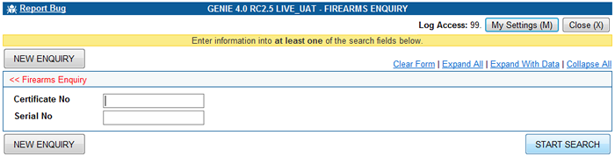

Systems available for search:
Firearms Information recorded for the Force Area on NFLMS
Search can be carried out via the Certificate number or Serial number fields. Partial data can be searched with the use of wildcards.

If you have a query please contact a member of the Genie Training Team on ext. 2751, 2950, 2750, 3473 or 5413

